Business Understanding

1. 📌 Project Overview
Uber Eats operates in a highly competitive food delivery market where customer expectations for fast delivery, quality service, and personalized experience are continuously increasing.
The business generates large volumes of data across orders, customers, restaurants, and feedback systems. However, this data is not being fully utilized to derive actionable insights for improving performance.
This project focuses on building a data-driven analytical solution to monitor key business metrics and support strategic decision-making.

2. Business Objectives
The project aims to achieve measurable business improvements:
- Increase total revenue by 10–15% through targeted restaurant partnerships and campaigns
- Reduce average delivery time by 15–20% to improve operational efficiency
- Improve average customer rating from ~3.7 to 4.2+
- Increase customer engagement in low-performing segments by 20–25%
- Improve performance of underperforming cities by 15–20%

3. 🧩 Key Business Questions
This analysis aims to answer the following critical business questions:
- Which cities and restaurants are generating the highest revenue?
- Which customer segments (age group, tier) contribute most to orders?
- How does delivery time impact customer ratings?
- What are the most frequently ordered items?
- Which payment methods and coupon strategies drive more transactions?
- Where are the performance gaps in terms of low ratings or low revenue?

4. 👥 Stakeholders
The key stakeholders involved in this project include:
- Product Manager
Responsible for overall product performance and feature improvements
- Marketing Team
Uses insights to design campaigns, offers, and customer engagement strategies
- Operations Team
Focuses on delivery efficiency and service quality
- Restaurant Partners
Aim to improve sales and customer satisfaction
- Senior Management
Uses insights for strategic and revenue-driven decisions

5. 📈 Success Metrics (KPIs)
The success of this project will be measured using the following KPIs:
- Total Revenue
- Number of Customers
- Average Delivery Time
- Average Customer Rating
- Order Volume by City / Restaurant
- Customer Segmentation Metrics

6. ⚙️ Scope of the Project

✅ In-Scope:
- Analysis of customer, order, and revenue data
- Evaluation of delivery performance and ratings
- Dashboard creation for business insights
- Identification of trends and patterns

❌ Out-of-Scope:
- Real-time tracking systems
- Delivery route optimization
- Backend system development
- Predictive modeling (future scope)

7. 🧠 Assumptions
- Data provided is accurate and representative of business operations
- Customer ratings reflect actual service quality
- Delivery time is a key factor influencing satisfaction
- All transactions are successfully recorded in the dataset

8. ⚠️ Constraints
- Limited historical data available
- No real-time data integration
- Possible data quality issues (missing or inconsistent values)
- Analysis limited to available variables

9. ⚠️ Limitations
While the project provides valuable insights, the following limitations should be considered when interpreting the results:
- Lack of Real-Time Data:
The analysis is based on historical data and does not reflect real-time business performance. As a result, immediate operational changes or live trends are not captured.
- Limited Dataset Scope:
The dataset used for analysis is limited in size and may not fully represent all business scenarios, customer behaviors, or seasonal variations.
- Assumptions on Customer Ratings:
It is assumed that customer ratings accurately reflect the overall service experience. However, ratings may be influenced by subjective factors not captured in the dataset.
- Restricted Data Variables:
Some potentially important factors (e.g., delivery distance, time of day, external conditions) are not available, which may impact deeper analysis.

🎯 Impact of Limitations
These limitations highlight the need for:
- Real-time data integration for better decision-making
- Expanded datasets for more comprehensive analysis
- Additional variables for deeper insights
Despite these constraints, the analysis provides a strong directional understanding of business performance and key improvement areas.

📌 10. 🔄 Data Flow & System Architecture (Final Version)

🔹 Data Flow Overview
This project follows a structured and simplified ETL (Extract, Transform, Load) pipeline to convert raw data into actionable business insights.
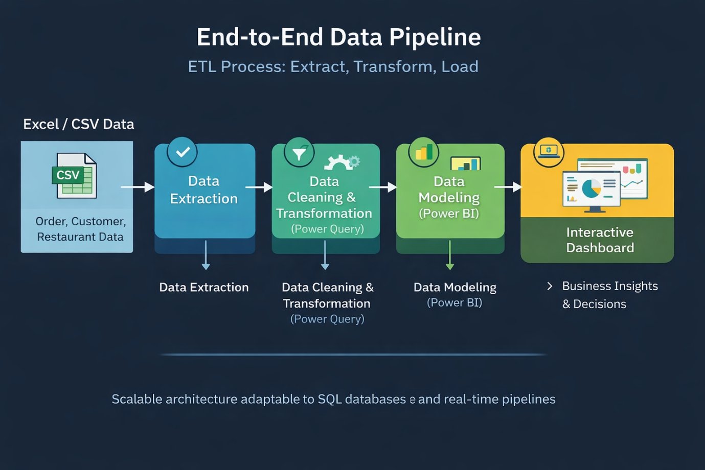

🔹 Explanation of Each Stage

📥 1. Data Source (Excel / CSV)
- The dataset contains order, customer, and restaurant data
- Serves as the raw input for analysis

🔍 2. Data Extraction
- Data is imported into Power BI
- Initial validation is performed to ensure completeness

🔄 3. Data Cleaning & Transformation (Power Query)
- Handling missing values
- Removing duplicates
- Standardizing formats (dates, categories)
- Preparing data for analysis

🧩 4. Data Modeling (Power BI)
- Creating relationships between tables
- Defining calculated columns and measures (KPIs)
- Structuring data for efficient querying

📊 5. Interactive Dashboard
- Visualizes KPIs such as revenue, delivery time, and ratings
- Enables filtering, drill-down, and user interaction

🎯 6. Business Insights & Decisions
- Converts data into actionable insights
- Supports decision-making for marketing, operations, and strategy

🔹 Scalability Consideration
While the current implementation uses Excel as the data source, the architecture is designed to scale for real-world applications:
- Data can be migrated to relational databases (e.g., SQL Server, MySQL)
- ETL pipelines can be automated for continuous data processing
- Real-time data integration can enable live dashboards
👉 The architecture follows a simplified ETL approach, making it adaptable to enterprise-level systems.

🎯 Business Value
- Provides clear visibility into how data is transformed into insights
- Ensures transparency in the analytics process
- Demonstrates readiness for real-world data environments
- Bridges the gap between technical implementation and business decision-making

